DNS, Data Encapsulation and Frame Examination

Learning Objectives
At completion of this lab, you will be able to:
- Use Wireshark to capture and analyze DNS message
- Understand how DNS works
- use nslookup and ipconfig commands
- Explain the header fields in an Ethernet II frame.
- understand data encapsulation

6. Report and Feedback on this lab
Answer all questions with supporting screenshots. Please fill in the following feedback form and append it to the report. Your feedback is valuable to us so that we can improve this lab, and make the course welcome.

For each task, please rate the following in the scale of 1 through 5:
- The degree of difficulty: 1 = too easy; 5 = too difficult
- The learning experience: 1 = learned nothing; 5 = learned a lot
- Your interest: 1 = no interest; 5= high interest
- Time used for the task: in minutes
Task | Difficulty (1—5) | Learning (1—5) | Interest (1—5) | Time ( min)
Task 0
Task 1
Task 2
Task 3
Task 4
Your suggestion/comment:

Background
When upper layer protocols communicate with each other, data at the sending host flows down the TCP/IP protocol layers and is encapsulated into a protocol data unit at lower layer, and finally encapsulated in a Layer 2 frame. For example, DNS message is often transported by UDP protocol on layer 4. So DNS message at the sending host is encapsulated in a UDP segment; the UDP segment is then encapsulated in an IP packet, and the IP packet is encapsulated finally in a layer 2 frame. The frame composition is dependent on the media access type, or the network. For example, if the media access is Ethernet, then the Layer 2 frame encapsulation will be Ethernet II.
When learning about data encapsulation and protocol operations, it is helpful to analyze the header information found in the protocol data units. The DNS protocol operation, ipconfig command, and Ethernet II frame header will be examined in this lab. Ethernet II frames can support various upper layer protocols.
For more background information, please read the lectures 02, 04-05, 10, 11.
Tasks
Task 0 Protocol Layers and Data Encapsulation
As we have discussed in Lecture 02, Internet is inter-connected networks based on TCP/IP protocols. Read the slides or textbook to learn how data goes through protocol layers and how data is encapsulated in the protocol data units. There are conventional names for the protocol data units for different layer protocols.
Question 1. What are names for the protocol data units (PDUs) for layer 4, layer 3, and layer 2 protocols in TCP/IP reference model by filling the follow form:
name for PDU of layer 4 protocols:
name for PDU of layer 3 protocol:
name for PDU of layer 2 protocol:
Task 1 DNS and nslookup
As we discussed, IP address is used to identify a host uniquely on the Internet. But IP address is not user-friendly and that is why domain name was introduced. The Domain Name System (DNS) translates host names to IP addresses, providing a critical role in the Internet infrastructure.
In this task, we practice the nslookup tool, which is available both in Linux/Unix and MS Windows. To run nslookup in MS Windows, you need to open the command line window by starting the command "cmd.exe". With nslookup, you can query any specified DNS server (by default, your local configured DNS server) for a DNS record. To accomplish this task, nslookup sends a DNS query to the specified DNS server, receives a DNS reply from that same DNS server, and displays the result.
Type the command "nslookup www.MIT.edu", and capture the output, as I did and showed below:
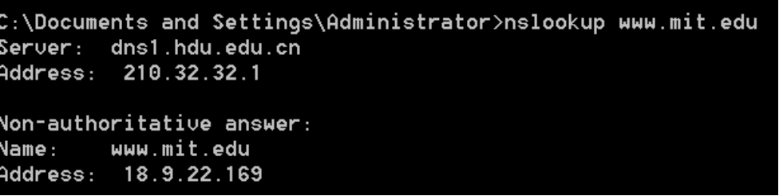
Question 2: What is the DNS server IP address that is used to query and find IP address for www.MIT.edu? And IP address for www.MIT.edu ?
Type the command “nslookup -type=NS hdu.edu.cn”, and capture the output, as I did and showed below:
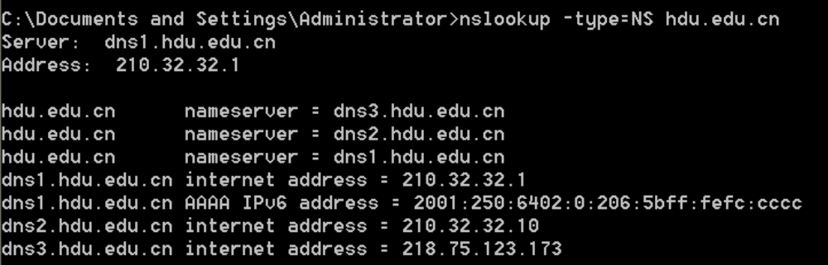
Question 3: What are domain name servers for hdu.edu.cn and their IP addresses?
Type the command “nslookup www.hdu.edu.cn dns2.hdu.edu.cn”, and capture the output, as I did and showed below:
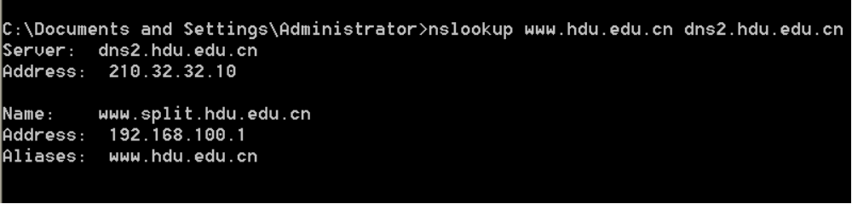
Question 4: Which DNS server is used to query and for name resolution?
You can also use nslookup to find the mapping from IP addresses to the host names. Type the commands “nslookup 192.168.156.101” and “nslookup course.comm.hdu.edu.cn”, and capture the output, as I did and showed below:
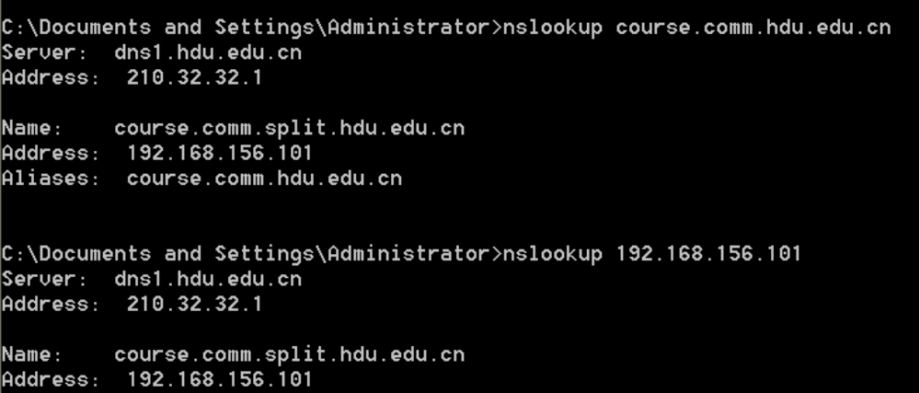
Question 5: Can a host have multiple host names? What is the IP address for moodle.tec.hkr.se? How many names do you find for this IP address?

Task 2 DNS and ipconfig
ipconfig (for Windows) and ifconfig (for Linux/Unix, interface configuration) are among the most useful tools for debugging network issues.
ipconfig can be used to show your current TCP/IP information, including your address, DNS server addresses, adapter (network interface card) type and so on. For example, if you want to find all this information about your host, simply enter the command “ipconfig /all” in the command line.
Read more on “using ipconfig” at http://support.microsoft.com/kb/314850.

Question 6: What is the IP address for your computer, and what is the local DNS server IP address?
ipconfig is also very useful for managing the DNS information stored in your host. To improve the networking performance, a host can cache DNS records it recently obtained. To view these cached records, you can use the command “ipconfig /displaydns”. Each entry shows the remaining Time to Live (TTL) in seconds. To clear the cache, enter the command “ipconfig /flushdns”. Flushing the DNS cache clears all entries and reloads the entries from the hosts file.

Task 3 DNS Protocol Analysis with WireShark
Now it is time to capture DNS protocol data and do the analysis with WireShark. Follow the steps to capture the DNS packets:
- close all other Internet applications to reduce the captured data
- start a web browser
- use ipconfig to empty the DNS cache in your computer
- start WireShark program, and enter the display filter “ip.addr==192.168.0.100 and dns”, where the IP address 192.168.0.100 should be the IP address for your computer. You find it in question 6.
- Start packet capture in WireShark
- Enter the url address http://www.ietf.org to your web browser to view the page.
- Stop the packet capture.
I got the following screenshot for this operation:
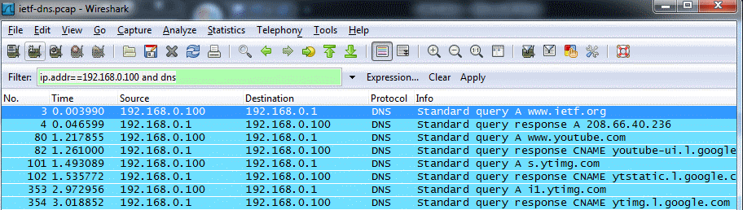
Answer the following questions:
Question 7: Locate the DNS query and response for resolving www.ietf.org. Are they sent over UDP or TCP?
Question 8: What is the destination port for the DNS query message? What is the source port
of DNS response message?
Question 9: To what IP address is the DNS query message sent? Use ipconfig to determine the IP address of your local DNS server. Are these two IP addresses the same?

Question 10: Examine the DNS query message. What “Type” of DNS query is it? Does the
query message contain any “answers”?

Question 11: Examine the DNS response message. How many “answers” are provided? What
do each of these answers contain?

Task 4 Ethernet Frame Examination
The format for an Ethernet frame is shown below:
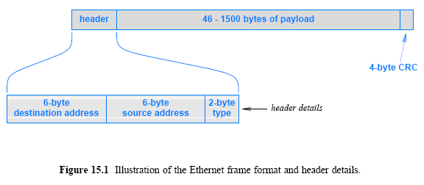
For info on MAC addresses, read slide 26 (Lecture 10). For finding NIC manufacturer, use the online server at http://www.pandapocket.com/mac/mac.py .

In WireShark with the captured DNS packets done in the last task, expand the frame information, as you could see my example:

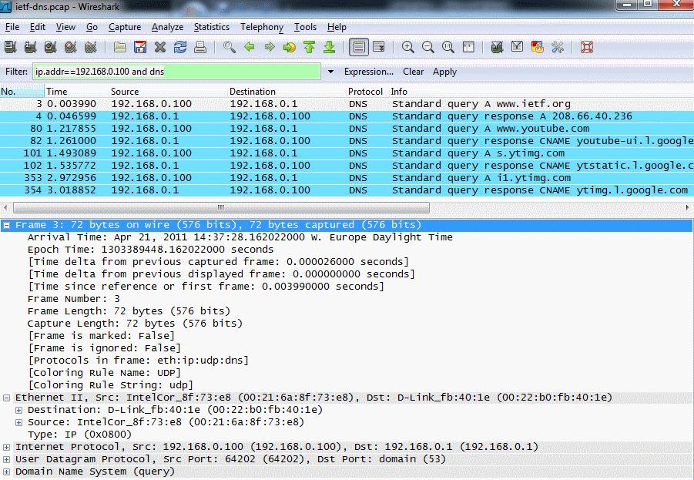

It shows that data contained in the Ethernet frame is an IP packet; the data contained in the IP packet is a UDP segment, and data in the UDP segment is DNS message! The total frame length is 72 bytes (excluding CRC parity bits).

For the Ethernet frame containing DNS query message for resolving www.ietf.org, answer the following questions:

Question 12: What is the destination MAC address? What is its NIC manufacturer, and what is the NIC serial number?

Question 13: What is the source MAC address? What is its NIC manufacturer, and what is the NIC serial number?

Question 14: what is the value in the type field? What does this value mean?

Now, change the display filter to “arp” in WireShark, so that only ARP packets are displayed, for example, I got:

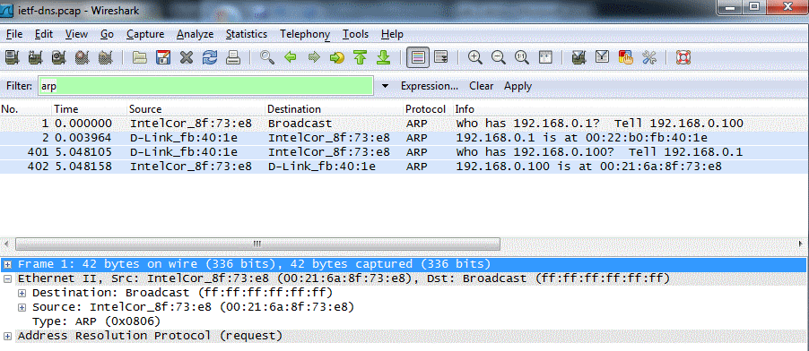

Locate a broadcast ARP message, and examine the Ethernet frame header, answer the questions:

Question 15: What is the destination MAC address? Is this address special? What does it mean?
Question 16: What is the source MAC address? What is its NIC manufacturer, and what is the NIC serial number? Is it a uni-cast address? Why?
Question 17: what is the value in the type field? What does this value mean?

